

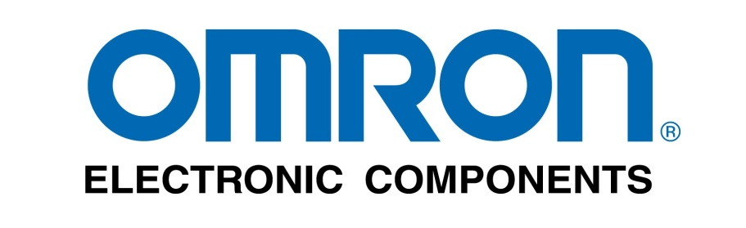 

**Project Sponsor: Omron Electronic Components**

**Faculty Advisor: Phil Lewis**

Team Members

Adrian Birylo Hangyoung Kim Jeffrey Grindel Zachary White, Syed Zaidi Jonathan Weiland Jonathan Hernandez Jarome Wisniewski Mitchell Geoffrey Aiman Kenzhedossova Thomas Demeter St. Hill Sherman Derek Wong

Table of Contents

Executive Summary 3

Purpose And Objectives 3

Organization And Approach 4

Analysis And Findings 4

Collusions And Recommendations 6

Appendices 7

# Executive Summary

IPRO 326: Engineering Solutions is at heart a consulting group. Throughout the semester we worked with OMRON, an automotive electronics manufacturer, helping them overcome issues with their manufacturing processes. We selected two of their issues to resolve from a comprehensive list of issues they are already working to solve. These two problems were selected due to the interests of the individuals in our IPRO and the feasibility of completion during the semester. The first process we tackled was sealing a fuel pump. This in itself had two problems, one being the breaking of the needle that dispensed the sealant as it was dispensing and the other being an inconsistency in the viscosity of the sealant. The second process we addressed was one where OMRON wished to consolidate an area devoted to the manufacturing of made-to-order parts, including being able to manufacture different parts at the same workstation as well as more efficient storage of parts. In the following report we hope to familiarize the reader with and to document our process with both problems.

## Purpose And Objectives

The purpose of IPRO 326 is to assist our sponsor OMRON with various manufacturing issues that currently exist in their production plants. The first issue that was looked at was the fuel pump controller line. The overall objective was to reduce the time it takes to make the fuel pump controller. The problems with this line had to do specifically with the dispensing of Loctite, which is a type of sealant. Two different things were occurring, the needle was breaking on bent pins on the casing, and Loctite was being dispensed inconsistently resulting in the casing not being held together properly. The second issue that our IPRO looked at was OMRON’s low volume, or service products. These products were taking up a large amount of area that they wanted to use to start manufacturing new products. The objective then was to reduce this area, by combining multiple products into one workstation, thus creating a Mixed Model Line workbench. In addition, OMRON faced problems with storing the parts for these low volume products. Our IPRO also set the objective to alleviate this issue by suggesting alternative storage techniques.

## Organization And Approach

Our IPRO 326 team was divided into two groups. Each group focused on one of the two issues faced by OMRON. The team structure was created to maximize every team member’s skills and to allow multiple areas of the project to be worked on simultaneously.  
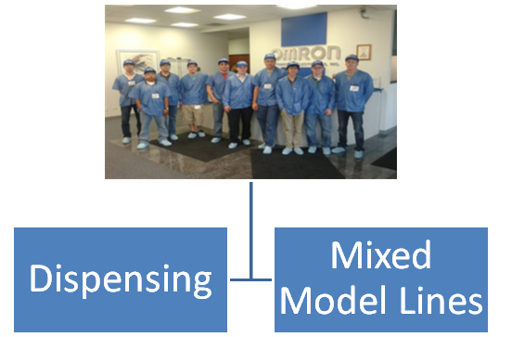  
For each group there was a group leader who was responsible for scheduling meetings and all the deliverables for their respective group. To learn more about the issues faced by OMRON both groups visited OMRON’s office multiple times. Each group stayed in constant contact with one of OMRON’s representative if the group needed more information and also to inform them the progress of the project.

## Analysis And Findings

Mixed Model Lines:  
For the mixed model lines, the one of the group’s largest findings was successfully calculating tac times for each of the separate parts, assembling it all into a easy to read spreadsheet and creating process flow diagrams for it all. Based on those findings and the need to create a good solution to all the wasted space by parts and workstations, the group came up with a mobile rail delivery system that would make use of quite a large amount of overhead space to minimize the floor space taken up by all such parts. The incoming parts would be placed in appropriately sized boxes and placed into a kit that would be hung on the rails and be sent to the individual workstations. The kit would contain then everything to create a part fully. The workstations were also rearranged to be a little easier to take parts off of the kits, combine them, and test them on one workstation in a little more logical manner than having to run to different places to get the previously mentioned things accomplished.

Dispensing Team

The Dispensing Team made the effort to get as much information about the dispensing station in OMRON’s Fuel Pump Module production line. The two general issues were an inconsistency on Loctite poured onto the modules’ casings before solidifying one unit and the perpetual needle breakage of the dispensing team. Besides understanding what errors came from these inefficiencies, the team sought to understand the issues in depth to make an informed and effective approach.  The data collected was made on site and conversations with managers, workers, and technicians gave the team a broader point of view. Data was collected in respect to the inconsistent Loctite Sealant volume dispensed onto the casings. Since the dispensing was done by a machine, it was baffling that such inconsistencies and leaks were existent. The first approach was to find how much the volume varied by. The team agreed that if the inconsistency was within a small margin of error, a simple change to the robot’s coordinate procedure would suffice to remove and take advantage of the leak at the end of the cycle. However, the findings showed that the inconsistencies were radical and the team then sought the root of the error. After understanding the procedure and the path of the Loctite before arriving to the dispensing station, it was found that the variable temperature was the root of the issue. The Loctite sealant encountered a ±7   ͦF change. This radical change in temperature made it difficult to guess the sealant’s viscosity at each dispensing cycle leading to an unpredictable volume at every process. The next step was to find ways to keep the sealant at stable temperatures before being dispense to find the reliability in volume expected. We found and have suggested implementing thermoelectric plates to make a better response to keep a stable temperature in the Loctite. The group also directed itself at minimizing the down time caused by errors in the production line. Throughout the dispensing machine’s cycle over the fuel pump module casings, any indentation in the piece’s pin could cause a broken needle and hours of down time. We evaluated the line workers’ actions and available space and time. This procedure allowed the team to fit a pin corrector of proper size and placement so as to not slow the overall time of production per piece.

## Collusions And Recommendations

Mixed Model Line:

Based on takt time calculations and the current factory layout, it was determined that it would be highly beneficial for OMRON to kit the product pieces, implement an overhead storage system, and to condense/modify the factory layout. Kitting is going provide a very organized system where all the parts one needs for a certain product will all be in one storage unit. This allows for easy restocking, where the material can be directly stored in these storage units instead of being stored in separate boxes on the plant floor. Also the kits can be directly brought to the workbench through the overhead storage system. This storage system not only is a way to get the material off the plant floor, reducing the needed space, but it also is a way to easy transfer the material to the workbenches. Once at the workbench, the bins within the storage system can be easily transferred to the workbench for assembly. To further reduce the footprint of the mixed model line factor area, the workbenches will now be able to support production of multiple similar product productions. From our findings we would recommend OMRON to take our storage system into consideration for their low-running mixed model line assembly. If OMRON would like to further research into this concept, it would be beneficial for the IPRO to continue. Future work may include, cost-analysis, floor-space reduction analysis, larger scale prototyping, and eventually full scale implementation of the system into their plant.

Dispensing Line:

Being a brand new manufacturing line for the OMRON plant, the GM fuel pump module line had some areas of improvement necessary for optimal efficiency. Going with this the team was able to design solutions for this line that would solve their manufacturing engineering problems with certain stations while being able to be integrated into the fluid motions of the workers. The new heating/cooling device would stop the massive amount of Loctite losses and allow the line to continuously operate without one of the workers having to stop every few seconds and clean something. This device would also reduce the differences between the finished products. The pin correcting module, while would take the worker more time, would be integrated into the line in a way that it would require one fluid motion right before an already automated section of the line. This would not bring the time of that section above the section with the longest process time therefore not increasing the total time of the line. Not only would it not hurt the overall time of the line but it would prevent a problem that could, and has been, shutting down the line for up to an hour. With these two new solutions and the improvements that OMRON has made themselves since the team first started working with them the fuel pump module line will be more efficient and faster than ever. Looking toward the future for this specific manufacturing line the way to go would be to rearrange the line to reflect the other older, more efficient lines in the plant. The IPRO team here and OMRON also predict making this line more automated, as of now it is nowhere near as automated as other lines in the plant.

## Appendices

So the actual expenses that we used for are ipro 326 this fall. The travel expenses that we used are $210.00 to get there and back. we used all of our supplies budget for are ipro day printing all that we need for that day, We used are team building expenses for a pizza party on our last class. We do have some money left over that we did not used  
  
The team member that are in ipro 326 are:  
Adrian Birylo     
Hangyoung Kim    
Jeffrey Grindel     
Zachary White     
Syed Zaidi                 
Jonathan Weiland     
Jonathan Hernandez    
Jarome Wisniewski    
Mitchell Geoffrey      
Aiman Kenzhedossova    
Thomas Demeter    
St. Hill Sherman    
Derek Wong

Are contact for this ipro are

Joneph Pornuevo

Phil Lewis

If you need there number and email please let us know .